## **Supplementary Materials**

# Supplementary Tables

**Table S1**: Markers identified by three feature selection methods (RAFS, Boruta, and MDFS).

|  |  |  |  |  |
| --- | --- | --- | --- | --- |
| Gene | Marker | In RAFS | In Boruta | In MDFS |
| IFIT5 | 203595_s_at | 0 | 1 | 1 |
| 203596_s_at | 1 | 1 | 1 |
| IFITM1 | 201601_x_at | 1 | 1 | 1 |
| 214022_s_at | 1 | 1 | 1 |
| CD300A | 209933_s_at | 1 | 1 | 1 |
| 217078_s_at | 0 | 1 | 1 |
| CD1C | 205987_at | 1 | 1 | 1 |
| SP3* | 213168_at | 1 | 1 | 1 |
| 229217_at | 0 | 0 | ? |
| 232709_at | 0 | 0 | ? |
| 238035_at | 0 | 0 | ? |
| SLC6A16 | 219820_at | 1 | 1 | 1 |
| HSPA6 | 117_at | 1 | 1 | 1 |
| HSPA7 | 213418_at | 0 | 1 | 1 |
| KIR2DL4 | 211245_x_at | 1 | 1 | 1 |
| 208426_x_at | 0 | 1 | 1 |
| 211242_x_at | 0 | 1 | 1 |
| GRHPR | 201347_x_at | 1 | 1 | 1 |
| 214864_s_at | 1 | 1 | 1 |
| 216308_x_at | 1 | 1 | 1 |
| TMEM163 | 1552626_a_at | 1 | 1 | 1 |
| 223503_at | 0 | 1 | 1 |
| COP1* | 1552617_a_at | 1 | 0 | 1 |
| 234950_s_at | 0 | 0 | ? |
| SHFL | 1555491_a_at | 1 | 1 | 1 |
| 218429_s_at | 0 | 1 | 1 |
| 53720_at | 0 | 1 | 1 |
| MLLT3 | 1569652_at | 1 | 1 | 1 |
| 204918_s_at | 1 | 1 | 1 |
| 204917_s_at | 0 | 1 | 1 |
| IRF1-AS1 | 1564276_at | 1 | 1 | 1 |
| 230405_at | 0 | 1 | 1 |
| 232253_at | 0 | 1 | 1 |
| HMGB1 | 200679_x_at | 0 | 0 | ? |
| 200680_x_at | 0 | 0 | ? |
| 214938_x_at | 0 | 0 | ? |
| 224731_at | 0 | 1 | 1 |
| 224734_at | 1 | 1 | 1 |
| ELL3 | 219517_at | 1 | 1 | 1 |
|  | 219518_s_at | 0 | 1 | 1 |
| GMDS | 204875_s_at | 1 | 1 | 1 |
|  | 214106_s_at | 1 | 1 | 1 |
| GALNT10 | 207357_s_at | 0 | 1 | 1 |
| 212256_at | 0 | 1 | 1 |
| 230906_at | 0 | 0 | ? |
|  | 235292_at |  | 1 | 1 |
|  | 220879_at |  | 1 | 1 |

**Table S3**. Selected Gene Ontology terms and their associations with seed proteins in the columns.For each Gene Ontology (GO) term, the number of proteins in the network associated with that term and statistical significance levels is shown using the following scheme: *****p *<* 10−15, ****p *<* 10−12, ***p *<* 10−9, **p *<* 10−6, *p *<* 10−3. a: GO:0006952 – defense response, 34∗∗∗∗∗; b: GO:0009615 – response to virus, 21∗∗∗∗∗; c: GO:0051607 – defense response to virus, 18∗∗∗∗∗; d: GO:0006955 – immune response, 34∗∗∗∗∗; e: GO:0002376 – immune system process, 40∗∗∗∗; f: GO:0006950 – response to stress, 45∗∗∗∗; g: GO:0034340 – response to type I interferon, 12∗∗∗∗; h: GO:0045087 – innate immune response, 23∗∗∗∗; i: GO:0034097 – response to cytokine, 27∗∗∗∗; j: GO:0019221 – cytokine-mediated signaling pathway, 22∗∗∗∗; k: GO:0060337 – type I interferon signaling pathway, 11∗∗∗; l: GO:0007166 – cell surface receptor signaling pathway, 29∗∗∗; m: GO:0045321 – leukocyte activation, 17∗∗; n: GO:0050793 – regulation of developmental processes, 28∗∗; o: GO:0010468 – regulation of gene expression, 35∗; p: GO:0045595 – regulation of cell differentiation, 20∗; q: GO:0043161 – proteasome-mediated ubiquitin-dependent protein catabolic process, 7 *<* 0*.*01. Associations identified by STRING are denoted by 1, associations inferred from analysis of the literature are denoted by *.

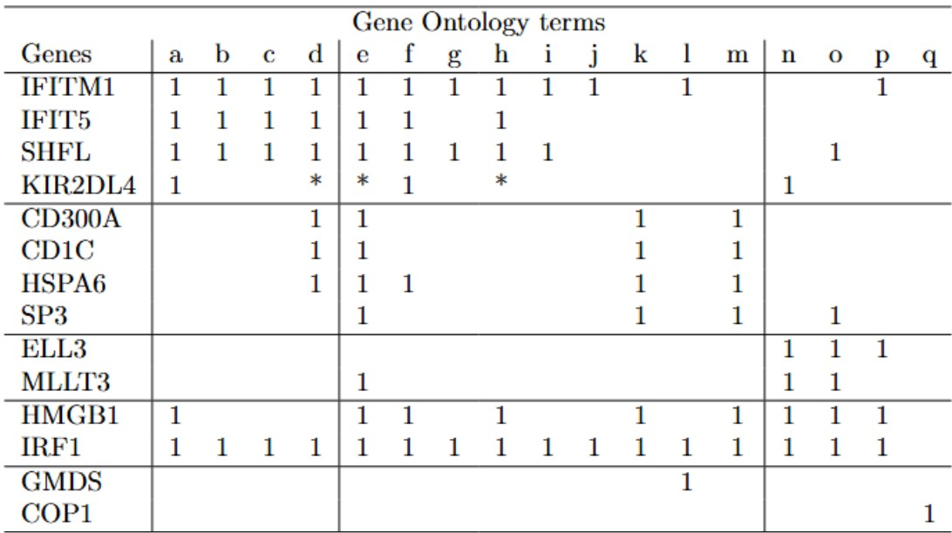

# Supplementary Figures

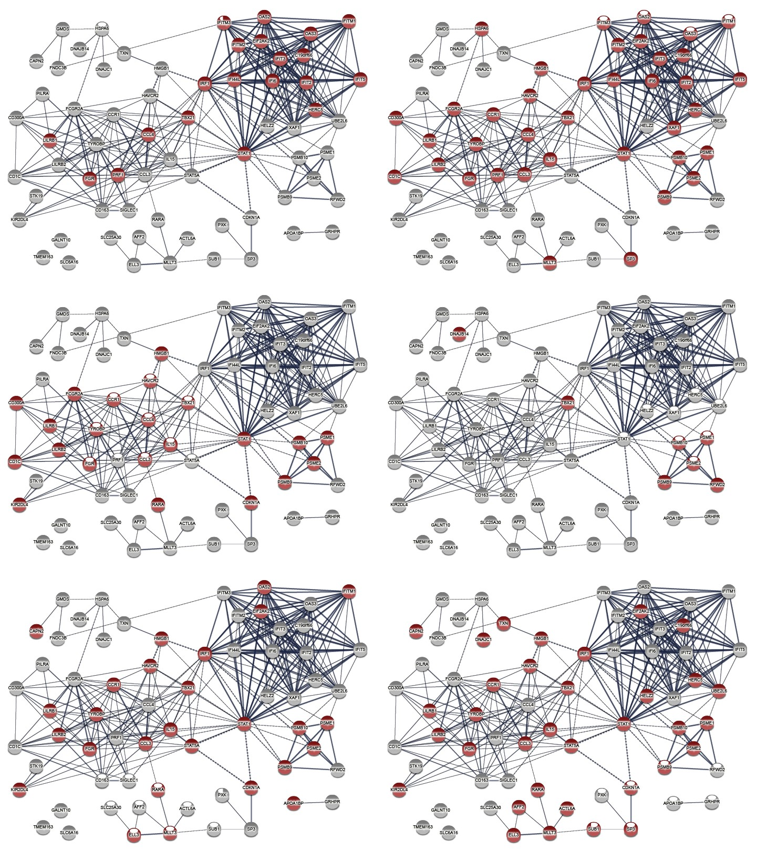

**Fig.S1.** Prominent Gene Ontology terms from the biological process hierarchy: top left – GO:0009615 (response to virus); top right – GO:0006955 (immune response); middle left GO:0002684 (positive regulation of the immune system process); middle right GO:0043161 – proteasome-mediated ubiquitin-dependent protein catabolic process; bottom left – GO:0050793 (regulation of developmental processes); bottom right – GO:0010468 (regulation of gene expression).



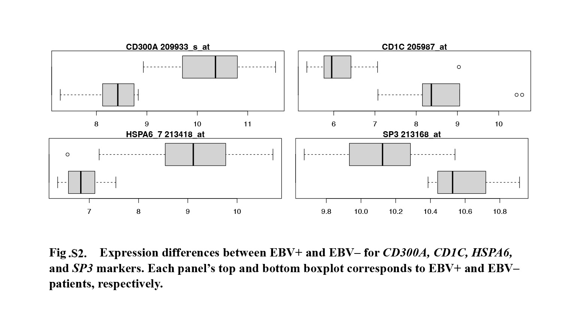 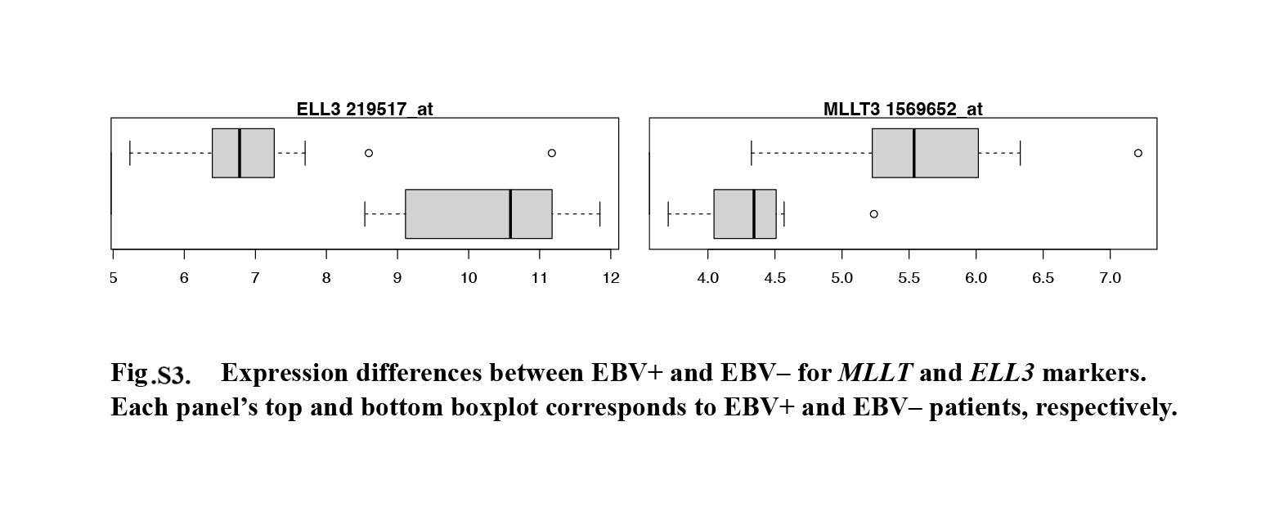 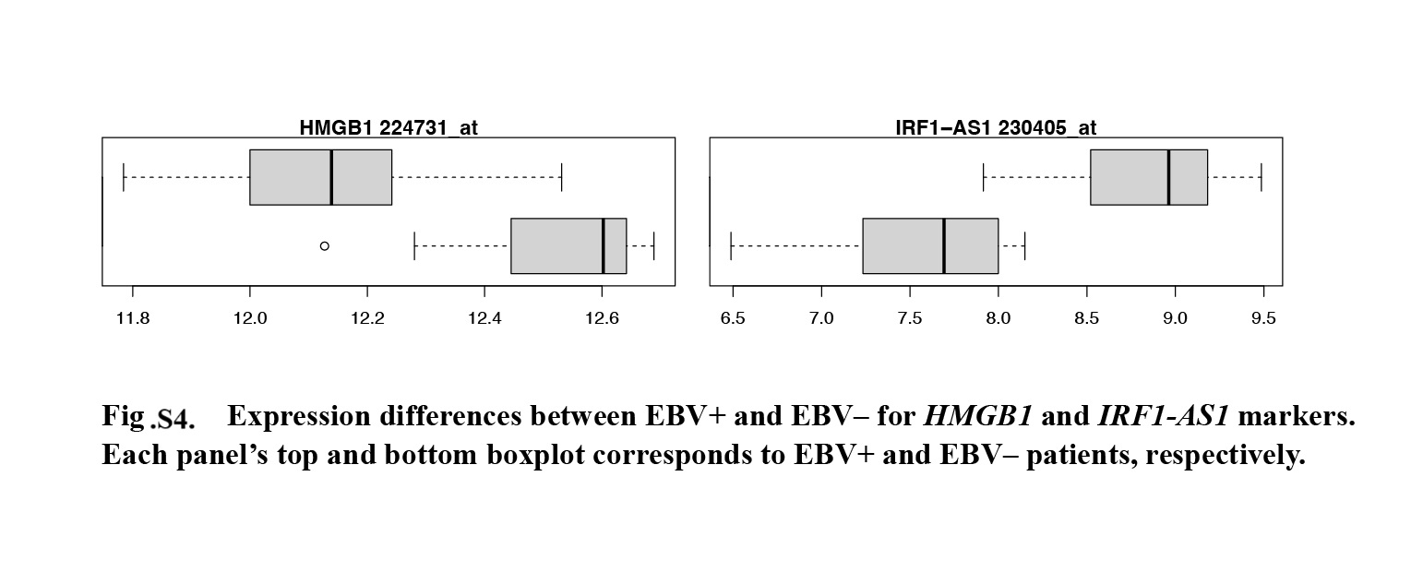

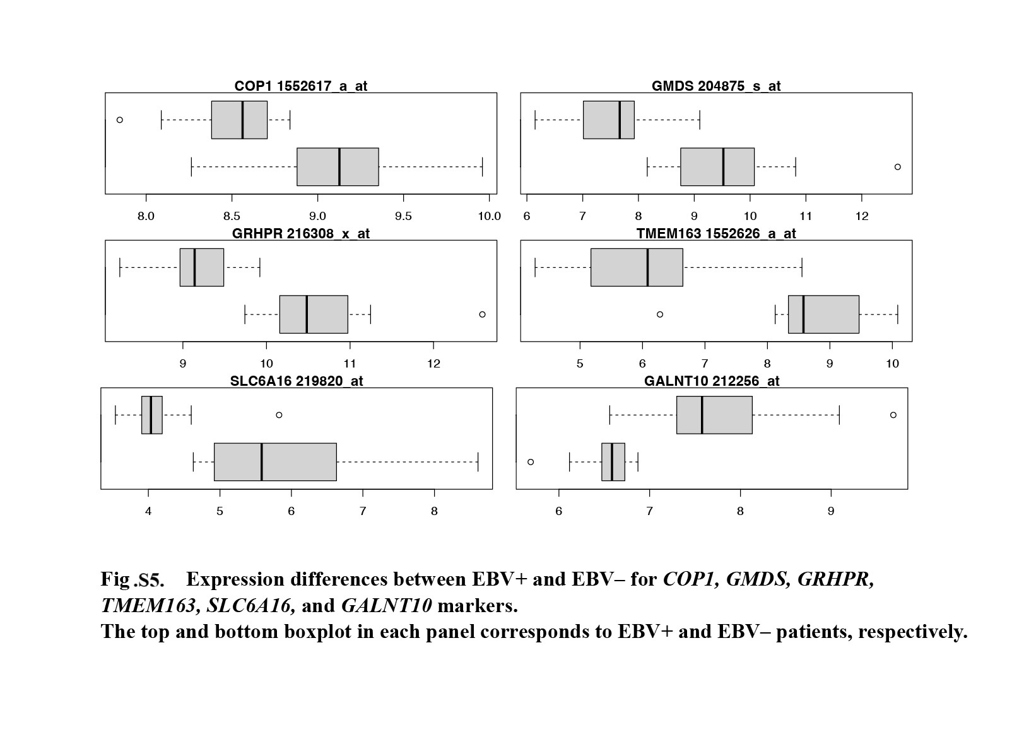

# Clusters of functionally related genes

Four clusters of genes differentially associated with the EBV status of PTLD patients were identified. The first cluster included genes, *IFITM1*, *SHFL*, *IFIT5*, and *KIR2DL4*. IFN-stimulated proteins such as *IFITM1* and *SHFL* exhibit antiviral activity (Smith et al., 2019). *IFITM1* may inhibit viral entry into the host cell cytoplasm (Narayana et al.,2015). *SHFL* can restrict expression of viral genes (Kinast et al. 2020; Rodriguez et al., 2019). The *IFIT5* mediates PPIs andcan modulate nuclear factor kappa B signaling (Zheng et al., 2015). The *KIR2DL4* plays important roles in the functional regulation of natural killer cells (Ding et al., 2022). The relationship of cluster #1 genes to immune responses could have been expected given our comparison of EBV+ and EBV– samples. However, three genes in this group, *IFIT5*, *IFITM1*,and *KIR2DL4*,are also associated with malignancy. The *IFITM1* is an oncogene involved in various cancers (Yu et al., 2011; Sari et al., 2011; Liu et al., 2019; Yan et al., 2019; Hatano et al.,2008; Chu et al., 2022). The *IFITM1* promotes tumor cell proliferation, inhibits cell death, and stimulates invasion and metastasis (Min et al., 2020). The *IFIT5* promotes the progression of renal, prostate, and bladder cancers (Liang et al.,2020; Lo et al., 2019, Huang et al., 2019). Due to the association with human papilloma virus oncogene E6, *IFIT5* may also be involved in the progression of oral squamous cell carcinoma (Pidugu et al., 2019). Another gene from the first cluster, *KIR2DL4*,is correlated with poor prognosis in non-small cell lung cancer (NSCLC) and with renal cell carcinoma development (Liang et al., 2020; He et al., 2016)

The second cluster included genes *CD300A*, *CD1C*, *HSPA6*,and *SP3*. The *CD300A* gene is a transmembrane glycoprotein in leukocytes that plays important roles in regulating their activation, proliferation, differentiation, and migration (Cao et al., 2021). High *CD300A* expression is associated with suppression of glioblastoma, NSCLC, and breast cancer (Du et al., 2018; Tang et al., 2018; Chen et al.,2023; Xu et al., 2023) and predicts poor survival in patients with acute myeloid leukemia (Xu et al.,2023). The *CD1C* is structurally related to class I major histocompatibility complex molecules but presents lipid and glycolipid antigens to T cells (Layre et al., 2014). The *CD1C* is a marker in cervical cancer (Uhlen et al., 2017)and cervical squamous cell carcinoma (Liu et al., 2020), and plays an antitumor role in NSCLS (Lu et al., 2019). The *HSPA6* is a heat shock protein family member involved in cell cycle regulation, hormone induction, and housekeeping (Song et al.2022; Hartl et al., 1996). The *HSPA6* upregulation after treatment of bladder and colorectal cancers correlates with tumor suppression (Safe et al., 2023). However, HSPA6 is a risk factor for early hepatocellular carcinoma recurrence and is related to its invasiveness and prognosis (Hedrick et al., 2016). The *SP3* is a transcription factor overexpressed in multiple tumors and is a negative prognostic factor for patient survival (Mansour et al., 2021).

The third cluster included genes *ELL3* and *MLLT3*. The *ELL3* plays an essential role in activating developmentally regulated genes by priming them to recruit the proper transcription initiation complex during cell differentiation (Lee et al., 2019). Interestingly, it both regulates and is regulated by p53protein, which is a key tumor suppressor (Kabra et al. 2022). The *MLLT3* regulates human hematopoietic stem cell self-renewal and engraftment (Kang et al.,2013).

# References

Cao Y, Ao T, Wang X, et al. CD300a and CD300f molecules regulate the function of leukocytes. Int Immunopharmacol. 2021; 93: 107373. doi: 10.1016/j.intimp.2021.107373.

Chen X, et al. CD1C is associated with breast cancer prognosis and immune infiltrates. BMC Cancer. 2023; 23(1): 129. doi:10.1186/s12885-023-10558-2.

Chu PY, Huang WC, Tung SL, et al. IFITM3 promotes malignant progression, cancer stemness and chemoresistance of gastric cancer by targeting MET/AKT/FOXO3/c-MYC axis. Cell Biosci. 2022; 12(1): 124. doi: 10.1186/s13578-022-00858-8.

Ding XF, Chen J, Ma HL, et al. KIR2DL4 promotes the proliferation of RCC cell associated with PI3K/Akt signaling activation. Life Sci. 2022; 293: 120320. doi: 10.1016/j.lfs.2022.120320.

Du X, Liu B, Ding Q, et al. CD300A inhibits tumor cell growth by downregulating AKT phosphorylation in human glioblastoma multiforme. Int J Clin Exp Pathol. 2018; 11(7): 3471-3478. PMID: 31949725; PMCID: PMC6962892.

Hartl FU. Molecular chaperones in cellular protein folding. Nature. 1996; 381(6583): 571-579. doi: 10.1038/381571a0.

Hatano H, Kudo Y, Ogawa I, et al. IFN-induced transmembrane protein 1 promotes invasion at early stage of head and neck cancer progression. Clin Cancer Res. 2008; 14(19): 6097-6105. doi: 10.1158/1078-0432.CCR-07-4761.

He Y, Bunn PA, Zhou C, et al. KIR 2D (L1, L3, L4, S4) and KIR 3DL1 protein expression in non-small cell lung cancer. Oncotarget. 2016; 7(50): 82104-82111. doi: 10.18632/oncotarget.13486.

Hedrick E, Cheng Y, Jin UH, et al. Specificity protein (Sp) transcription factors Sp1, Sp3 and Sp4 are non-oncogene addiction genes in cancer cells. Oncotarget. 2016; 7(16): 22245-56. doi: 10.18632/oncotarget.7925.

Huang J, Lo UG, Wu S, et al. The roles and mechanism of IFIT5 in bladder cancer epithelial-mesenchymal transition and progression. Cell Death Dis. 2019; 10(6):437.

doi: 10.1038/s41419-019-1669-z.

Kabra A, Bushweller J. The Intrinsically Disordered Proteins MLLT3 (AF9) and MLLT1 (ENL) - Multimodal Transcriptional Switches With Roles in Normal Hematopoiesis, MLL Fusion Leukemia, and Kidney Cancer. J Mol Biol. 2022; 434(1): 167117. doi: 10.1016/j.jmb.2021.167117.

Kang R, Zhang Q, Zeh HJ 3rd, et al. HMGB1 in cancer: good, bad, or both? Clin Cancer Res. 2013; 19(15): 4046-4057. doi: 10.1158/1078-0432.CCR-13-0495.

Kinast V, Plociennikowska A, Anggakusuma, et al. C19orf66 is an interferon-induced inhibitor of HCV replication that restricts formation of the viral replication organelle. J Hepatol. 2020; 73(3): 549-558. doi: 10.1016/j.jhep.2020.03.047.

Liang R, Li X, Zhu X. Deciphering the Roles of IFITM1 in Tumors. Mol Diagn Ther. 2020; 24(4): 433-441. doi: 10.1007/s40291-020-00469-4.

Liu X, Chen L, Fan Y, et al. IFITM3 promotes bone metastasis of prostate cancer cells by mediating activation of the TGF-β signaling pathway. Cell Death Dis. 2019; 10(7): 517. doi: 10.1038/s41419-019-1750-7.

Mansour MA. SP3 is associated with migration, invasion, and Akt/PKB signalling in MDA-MB-231 breast cancer cells. J Biochem Mol Toxicol. 2021; 35(3): e22657. doi: 10.1002/jbt.22657.

Min J, Hu J, Luo C, et al. IFITM3 upregulates c-myc expression to promote hepatocellular carcinoma proliferation via the ERK1/2 signalling pathway. Biosci Trends. 2020; 13(6): 523-529. doi: 10.5582/bst.2019.01289.

Narayana SK, Helbig KJ, McCartney EM, et al. The Interferon-induced Transmembrane Proteins, IFITM1, IFITM2, and IFITM3 Inhibit Hepatitis C Virus Entry. J Biol Chem. 2015; 290(43): 25946-59. doi: 10.1074/jbc.M115.657346.

Layre E, de Jong A, Moody DB. Human T cells use CD1 and MR1 to recognize lipids and small molecules. Curr Opin Chem Biol. 2014; 23: 31-8. doi: 10.1016/j.cbpa.2014.09.007.

Lee JY, Lee SH, Kim KS, et al. Ell3 functions as a critical decision maker at the crossroad between stem cell senescence and apoptosis. Stem Cell Res Ther. 2019; 10(1): 32. doi: 10.1186/s13287-019-1137-9.

Liu J, Wu Z, Wang Y, et al. A prognostic signature based on immune-related genes for cervical squamous cell carcinoma and endocervical adenocarcinoma. Int Immunopharmacol. 2020; 88: 106884. doi: 10.1016/j.intimp.2020.106884.

Lo UG, Bao J, Cen J, et al. Interferon-induced IFIT5 promotes epithelial-to-mesenchymal transition leading to renal cancer invasion. Am J Clin Exp Urol. 2019; 7(1): 31-45. PMID: 30906803; PMCID: PMC6420704.

Lu Y, Xu W, Gu Y, et al. Non-small Cell Lung Cancer Cells Modulate the Development of Human CD1c+ Conventional Dendritic Cell Subsets Mediated by CD103 and CD205. Front Immunol. 2019; 10: 2829. doi: 10.3389/fimmu.2019.02829.

Pidugu VK, Pidugu HB, Wu MM, et al. Emerging Functions of Human IFIT Proteins in Cancer. Front Mol Biosci. 2019; 6: 148. doi: 10.3389/fmolb.2019.00148.

Rodriguez W, Srivastav K, Muller M. C19ORF66 Broadly Escapes Virus-Induced Endonuclease Cleavage and Restricts Kaposi's Sarcoma-Associated Herpesvirus. J Virol. 2019; 93(12): e00373-19. doi: 10.1128/JVI.00373-19.

Safe S. Specificity Proteins (Sp) and Cancer. Int J Mol Sci. 2023; 24(6): 5164. doi: 10.3390/ijms24065164.

Sari IN, Yang YG, Phi LT, et al. Interferon-induced transmembrane protein 1 (IFITM1) is required for the progression of colorectal cancer. Oncotarget. 2016; 7(52): 86039-86050. doi: 10.18632/oncotarget.13325.

Smith SE, Busse DC, Binter S, et al. Interferon-Induced Transmembrane Protein 1 Restricts Replication of Viruses That Enter Cells via the Plasma Membrane. J Virol. 2019; 93(6): e02003-18. doi: 10.1128/JVI.02003-18.

Song B, Shen S, Fu S, et al. HSPA6 and its role in cancers and other diseases. Mol Biol Rep. 2022; 49(11): 10565-10577. doi: 10.1007/s11033-022-07641-5.

Tang Z, Cai H, Wang R, et al. Overexpression of CD300A inhibits progression of NSCLC through downregulating Wnt/β-catenin pathway. Onco Targets Ther. 2018; 11: 8875-8883. doi: 10.2147/OTT.S185521.

Uhlen M, Zhang C, Lee S, et al. A pathology atlas of the human cancer transcriptome. Science. 2017; 357(6352): eaan2507. doi: 10.1126/science.aan2507.

Xu ZJ, Jin Y, Zhang XL, et al. Pan-cancer analysis identifies CD300 molecules as potential immune regulators and promising therapeutic targets in acute myeloid leukemia. Cancer Med. 2023; 12(1): 789-807. doi: 10.1002/cam4.4905.

Yan J, Jiang Y, Lu J, et al. Inhibiting of Proliferation, Migration, and Invasion in Lung Cancer Induced by Silencing Interferon-Induced Transmembrane Protein 1 (IFITM1). Biomed Res Int. 2019; 2019: 9085435. doi: 10.1155/2019/9085435.

Yu F, Ng SS, Chow BK, et al. Knockdown of interferon-induced transmembrane protein 1 (IFITM1) inhibits proliferation, migration, and invasion of glioma cells. J Neurooncol. 2011; 103(2): 187-195. doi: 10.1007/s11060-010-0377-4.

Zheng C, Zheng Z, Zhang Z, et al. IFIT5 positively regulates NF-κB signaling through synergizing the recruitment of IκB kinase (IKK) to TGF-β-activated kinase 1 (TAK1). Cell Signal. 2015; 27(12): 2343-54. doi: 10.1016/j.cellsig.2015.08.018.